**Loyalty Manage System**

User Case Model

|  |  |
| --- | --- |
| Date | 01/23/2010 |
| Version | 1.0 |
| Status | Draft |
| Author | Hung Pham |
| Review By | Dat Tran |
| Approved By |  |

**Revision History**

|  |  |  |  |
| --- | --- | --- | --- |
| Date | Version | Description | Author |
| 01/23/2010 | 1.0 | Initial draft | Hung Pham |
| 01/28/210 | 1.1 | Modify user case  Change picture of Usercase. Modify usercase description section “Redemption” and “Banlance Inquiry”. | Hung Pham |

Table of Contents

1 Introduction 3

1.1 Purpose 3

1.2 Preferences 3

2 User Model 3

3 Actors 3

4 User Cases 4

# Introduction

## Purpose

The purpose of this document is to give a User Case View of the project.This document gives a high level view of new Loyalty Manage System from the User’s perpestive.The actor and user case of the project are list along with a brief description. The relationships between the actors and the user cases are also capture with User Case diagram.

## Preferences

-Loyalty Manage System vision.

# User Model

User Case diagram

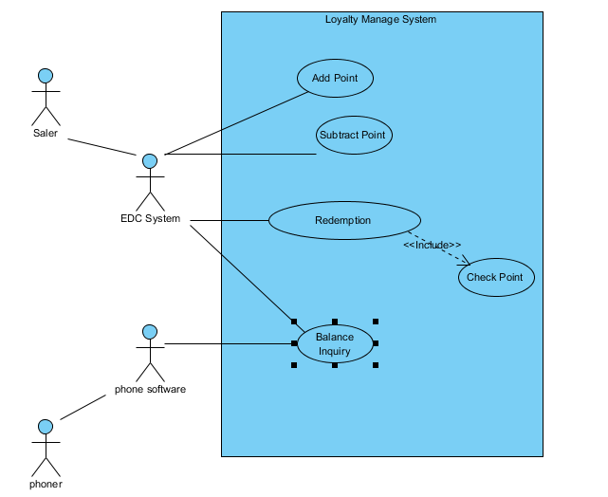

# Actors

|  |  |
| --- | --- |
| Actor | Actor Description |
| Saler | Saler of the book store that strike the card to EDC System |
| EDC System | Direct interactive LMS system by send ISO8583 message to LMS system and display the result. |
| Phoner | That user is user phone to query their point. |
| Phone Software | Support to read bar code and send it to LMS system by ISO 8583 Standar and display the result. |

# User Cases

|  |  |  |
| --- | --- | --- |
| User Case ID | UserCase Name | UserCase Description |
| UC_LMS_01 | Add Point | Add point to the database conresponding with value of product which customer buy in bookstore. |
| UC_LMS_02 | Subtract Point | Subtract point to the database when customer return book to book store and depends on value of product which customer return in bookstore. |
| UC_LMS_03 | Redemption | Redemption point to get present conresponding with that point. |
| UC_LMS_04 | Check Point | Check Point for exchange point to get present. |
| UC_LMS_05 | Banlance Inquiry | Report point and information of customer with customer ID. |